“Suniy intellekt asoslari “ fanidan
Xudoyberdiyev Asadbekning 2-topshiriqi

1-masala: faylga bir nechta satr yozish: output.txt faylini oching, unga 3 ta satr yozing. So’ngra faylni o’qib har bir satrni alohida chiqarib bering.
with open("output.txt", "w") as file:
file.write("Birinchi satr\n")
file.write("Ikkinchi satr\n")
file.write("Uchinchi satr\n")
# Faylni o'qib, har bir satrni alohida chiqarish
with open("output.txt", "r") as file:
for line in file:
print(line.strip()) # .strip() - satrdan ortiqcha bo'sh joylarni olib tashlaydi
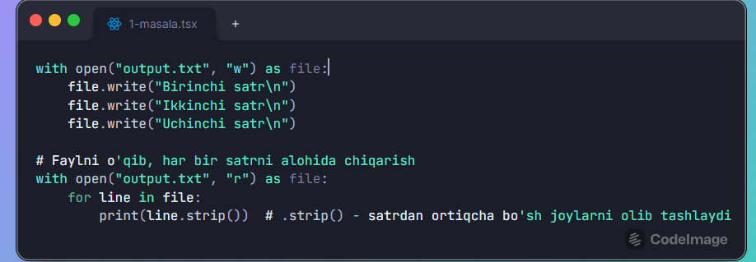

2-masala: fayl nomini va kengaytmasini ajratish: os.path.splitext() yordami report.pdf fayl nomi va kengaytmasini ajratib natijani ekranga chiqarib bering.
import os
file_name = "report.pdf"
# Fayl nomi va kengaytmasini ajratish
name, extension = os.path.splitext(file_name)
# Natijani chiqarish
print("Fayl nomi:", name)
print("Kengaytma:", extension)
